

**UI Guideline**

ShopT - React Native Code Challenge

Version: 1.0

Author: Anh Nguyen

Created date: 12-10-2019

Project: ShopT – React Native code challenge

I. Introduction 3

1. Purpose of the document 3

2. Modification history 3

3. Relevant documents 3

I. Design 4

II. UI Guide 6

1. Splash page 6

2. Login page 7

3. Home page 8

4. Cart popup 9

5. Product Detail 10

6. Check out page 11

7. Shipping address popup 12

8. Payment method popup 13

9. Confirmation page 14

# Introduction

## Purpose of the document

Documents from the user's perspective. Documentation, detailing the functions of shopT help developers build the application as well as guide users to use this application.

## Modification history

|  |  |  |  |
| --- | --- | --- | --- |
| **Version** | **Modification date** | **Author** | **Content summary** |
| 1.0 | 12-10-2019 | Anh Nguyen | Describe the function and UI. |
|  |  |  |  |
|  |  |  |  |
|  |  |  |  |

## Relevant documents

|  |  |  |
| --- | --- | --- |
| **Name** | **Created date** | **Author** |
| User Requirements Specification | 12-10-2019 | Anh Nguyen |
|  |  |  |

# Design

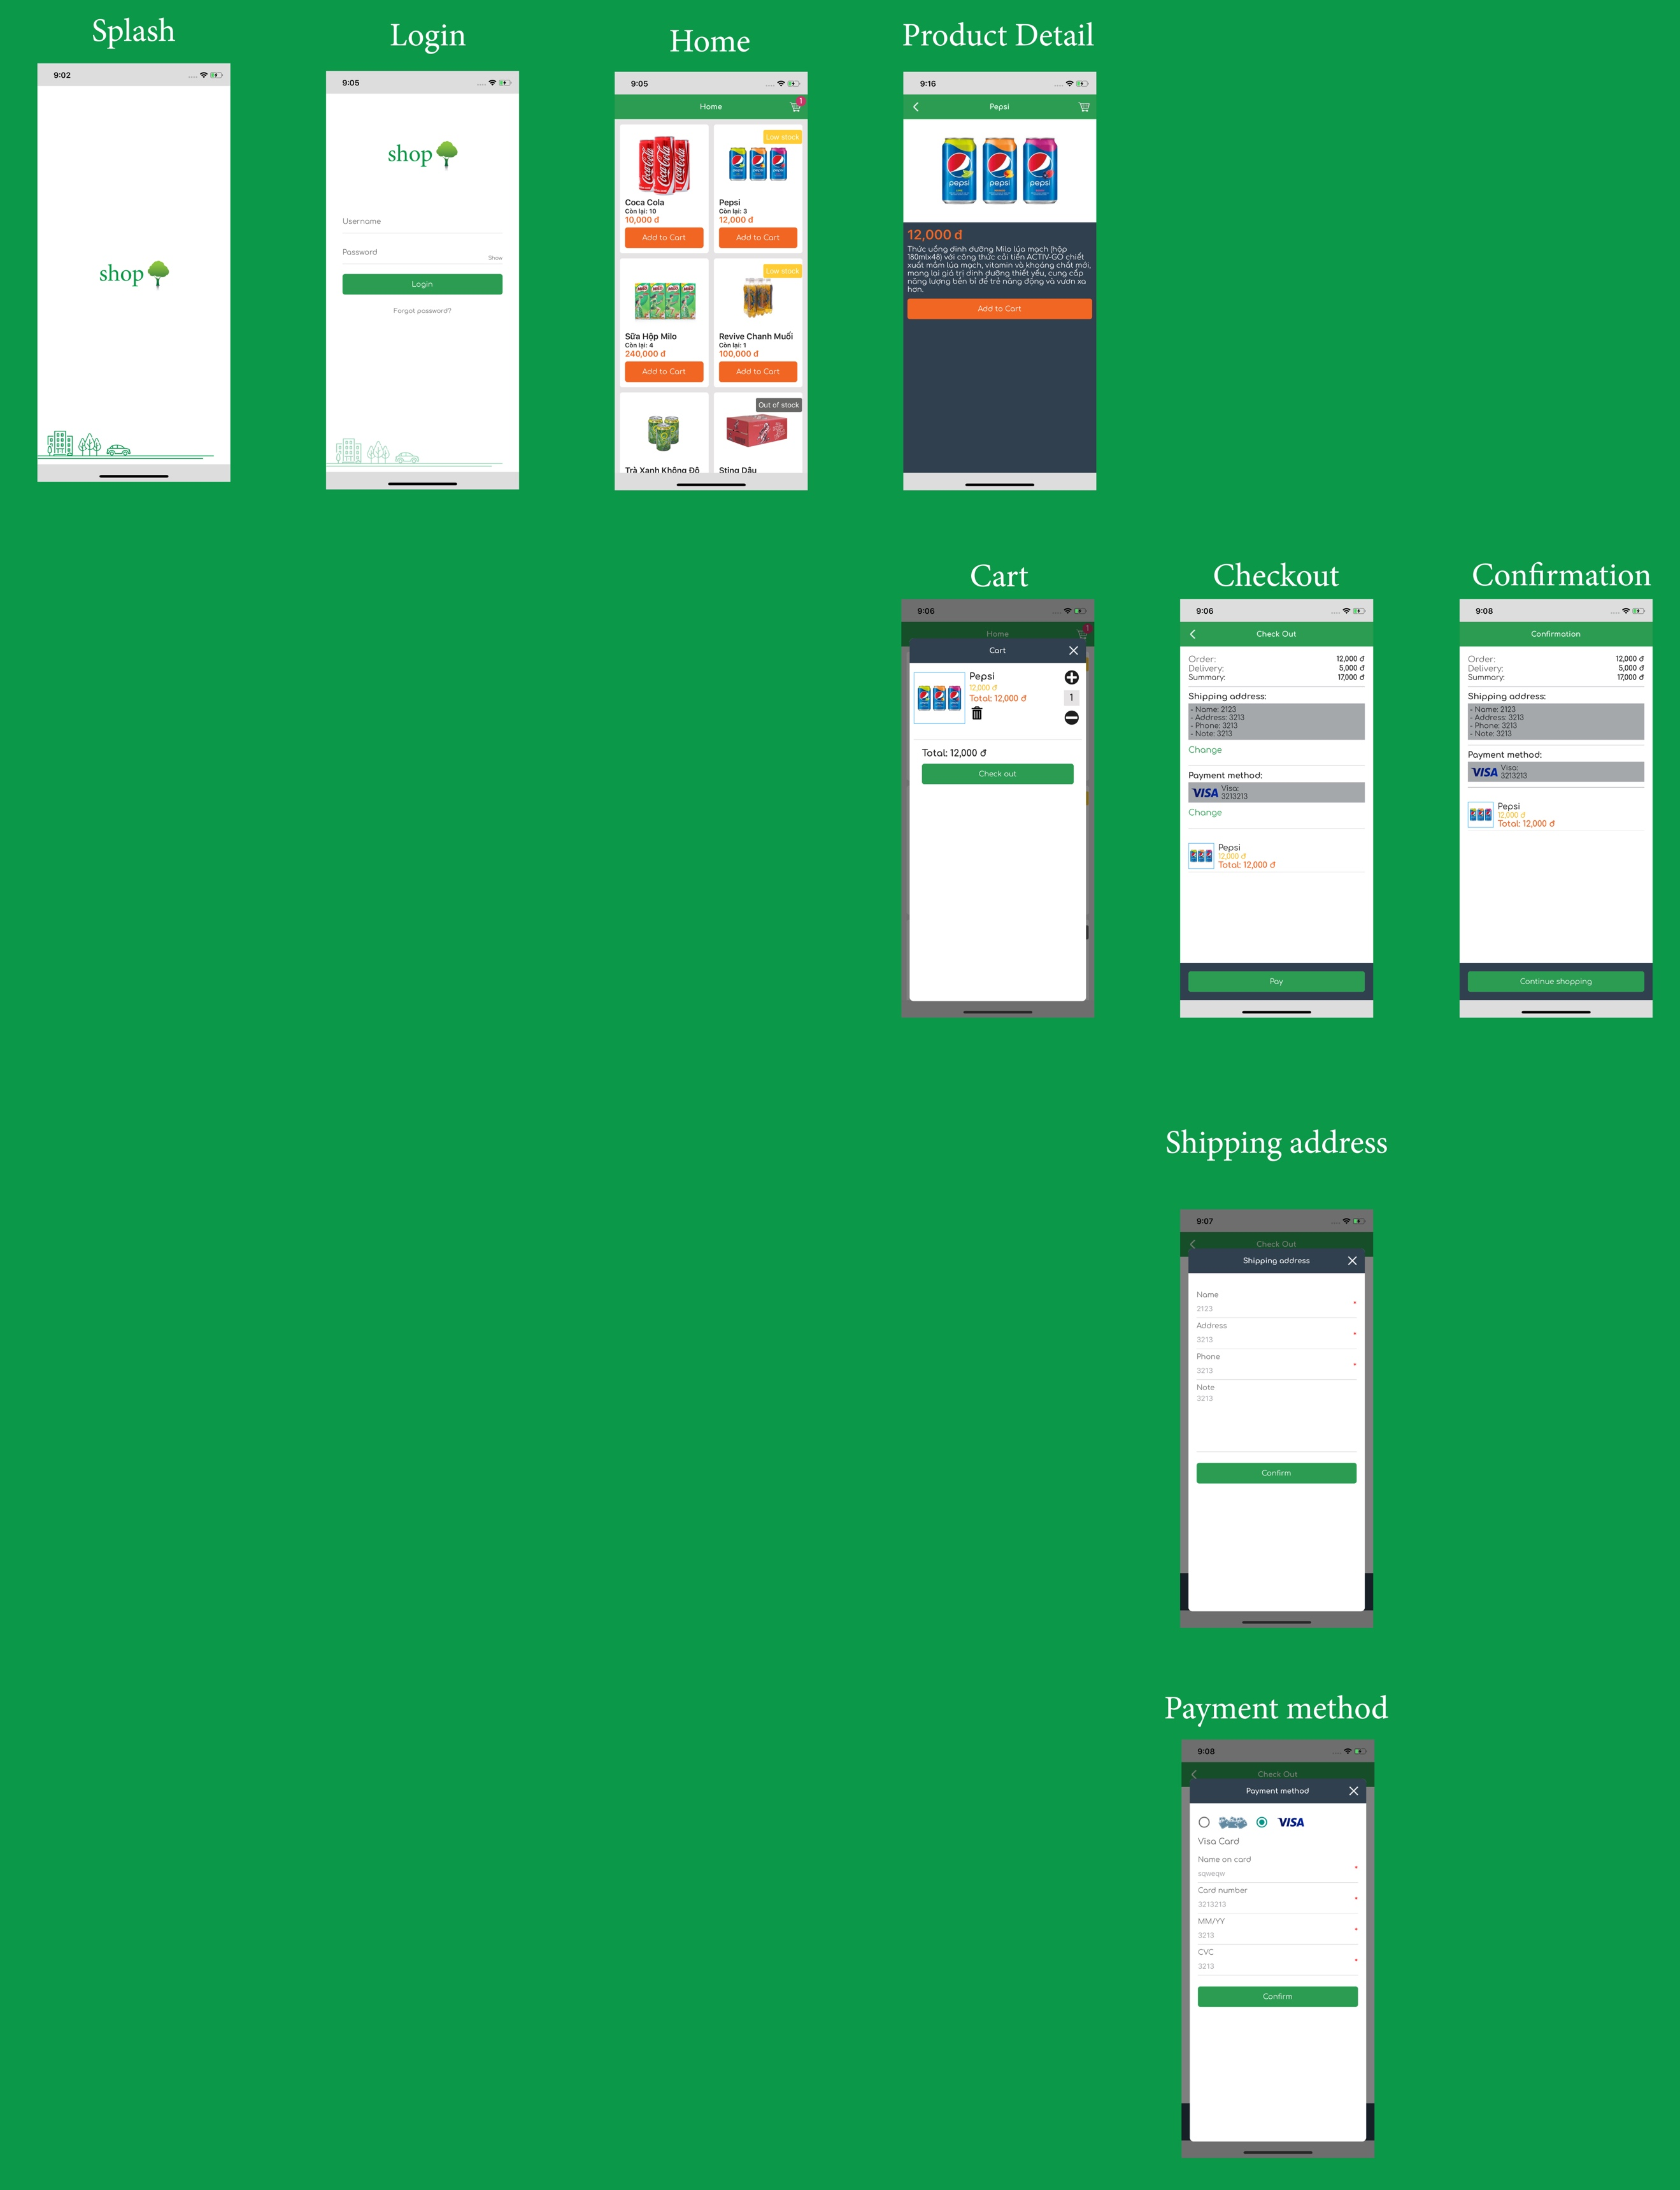

* Splash page
* Login page
* Home page
  + Cart popup
* Product detail page
  + Cart popup
* Check out page
  + Shipping address popup
  + Payment method popup
* Confirmation page

# UI Guide

## Splash page

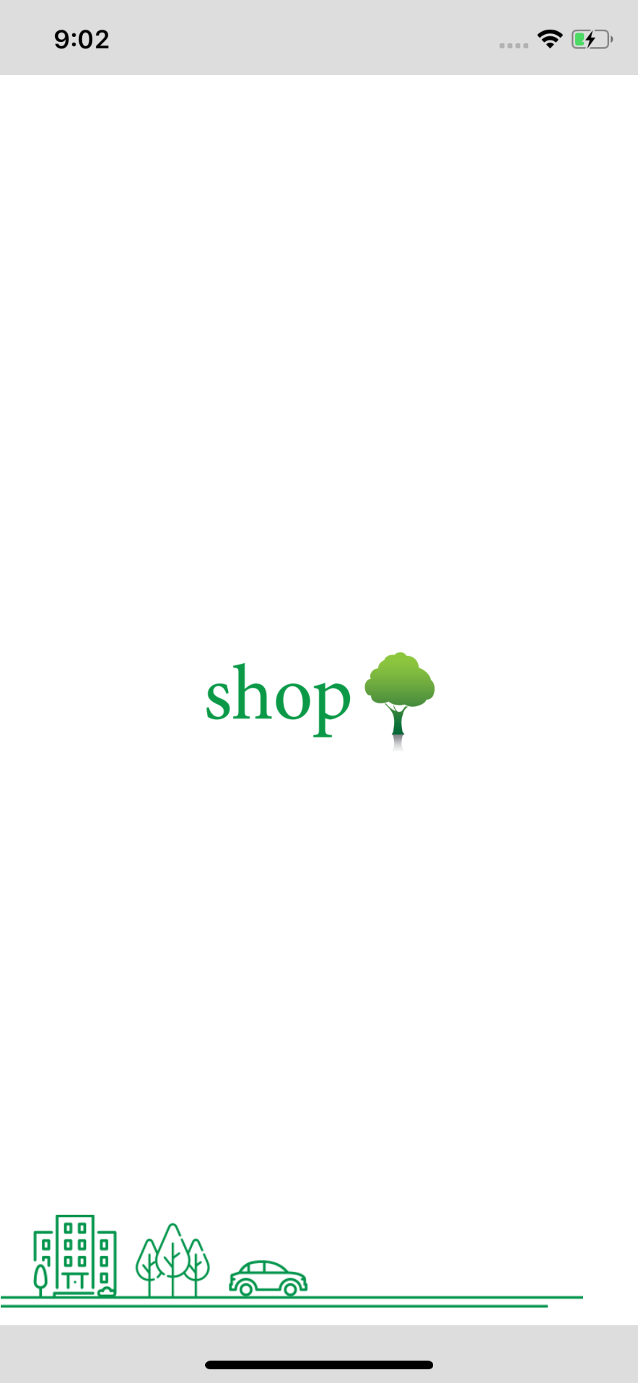

* Auto navigate to Login page with animation.

## Login page

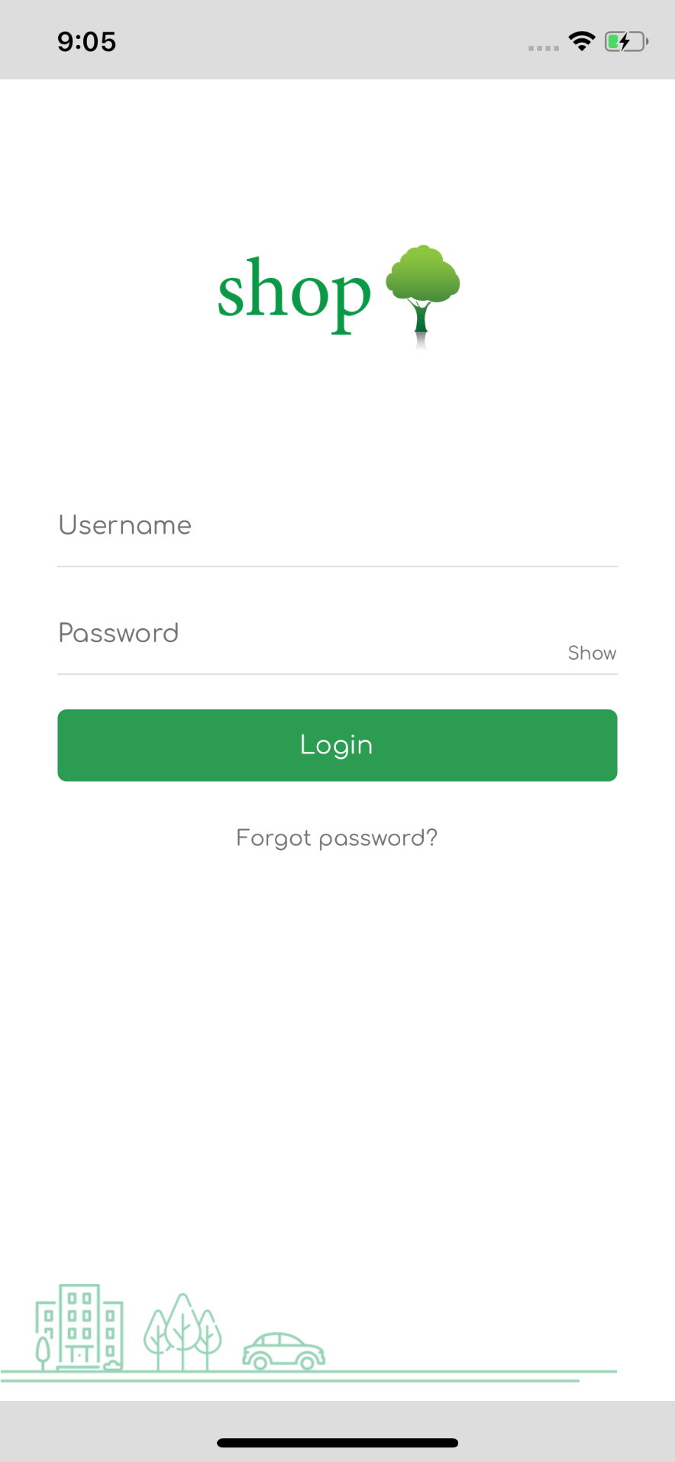

After user fill the username and password and press Login

* Login Success: Navigate to Home page
* Login Faile: Show popup warning “Error ...”

## Home page

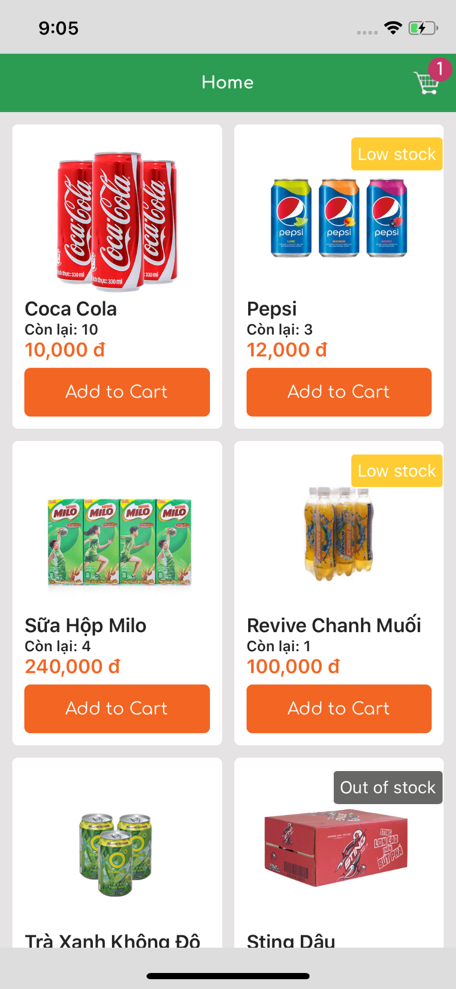

Show product List:

* Image
* Name
* Item has left
* Price
* Tag:
  + Low Stock: if item stock <= low stock in setting
  + Out of Stock: if item stock <= out of stock in setting
* Function:
  + Cart:
    -  Open cart popup
  + Add to cart:
    -  Add 1 item to cart

## Cart popup

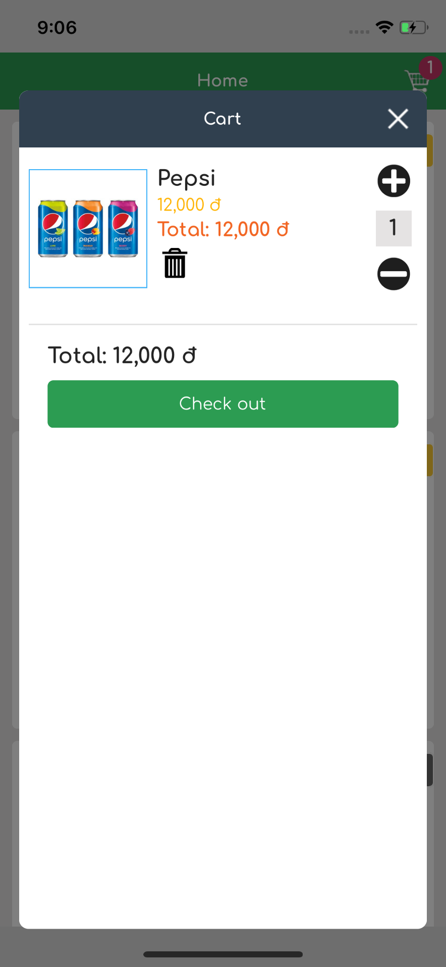

Show cart item List:

* Image
* Name
* Price
* Total price
* Amount of item

Function:

* + Add item:
    -  If amount < stock: add 1 to amount
  + Minus item:
    - minus 1 from amount
    - If amount =1 remove the item from cart list
  + Remove item
    -  Remove the iem from cart list
  + Check out
    -  Navigate to Check out page

## Product Detail

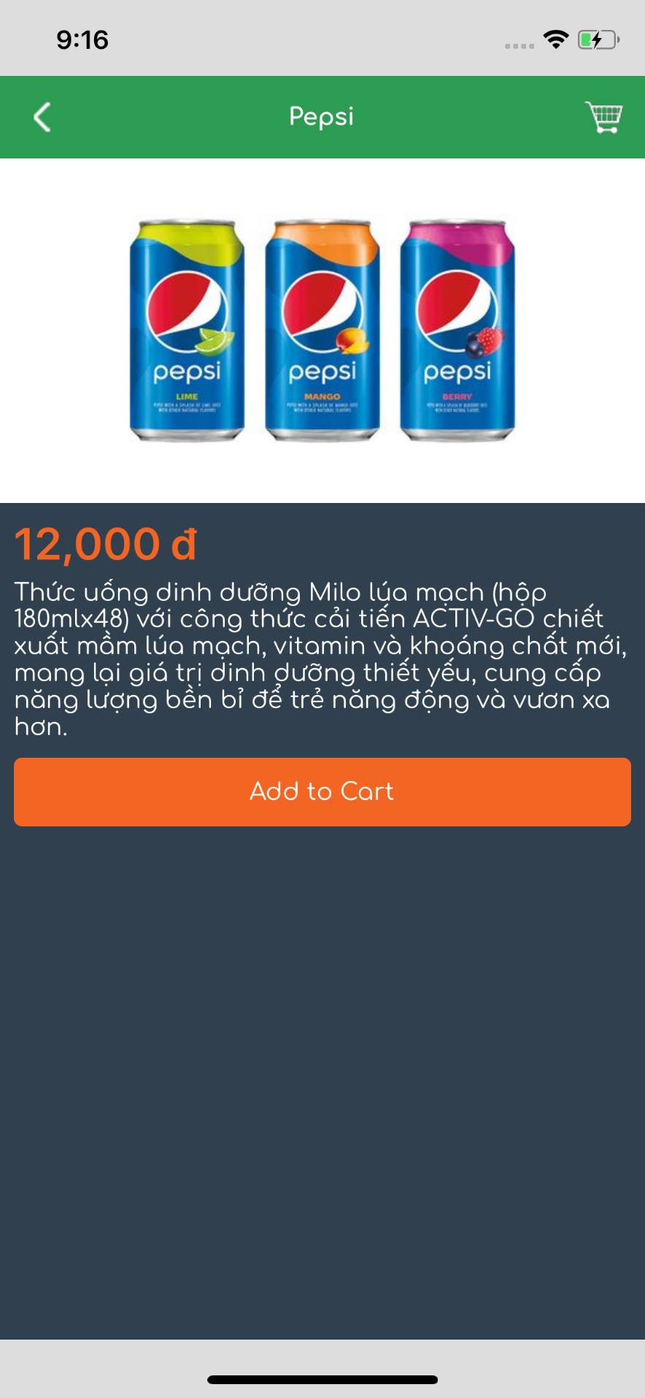

Show product detail:

* Image
* Name
* Long description
* Price

Function:

* Cart:
  +  Open cart popup
* Add to cart:
  +  Add 1 item to cart

## Check out page

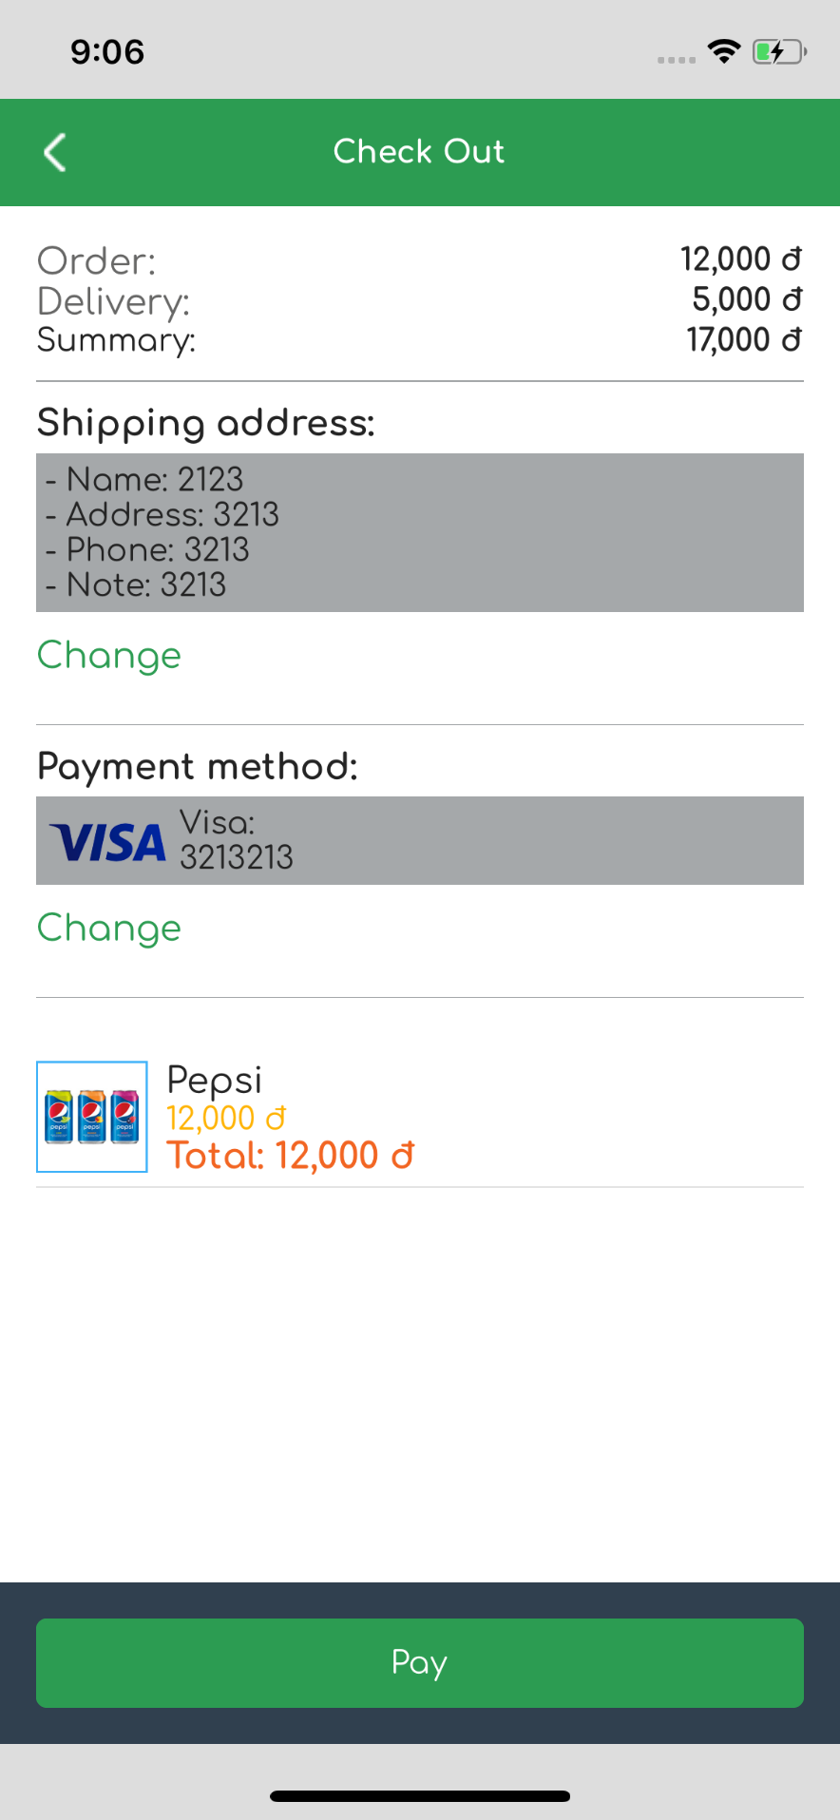

Show check out detail:

* Order money
* Delivery fee
* Summary money
* Shipping addres
* Payment method
* List item:
  + Image
  + Name
  + Price
  + Total price

Function:

* Change shipping address:
  + Open shipping address popup
* Change payment method
  +  Open payment method popup
* Pay:
  +  If shipping address and payment method are not null: Navigate to Confirmation page.
  + If shipping address or payment method are null: Show popup warning “Check again”

## Shipping address popup

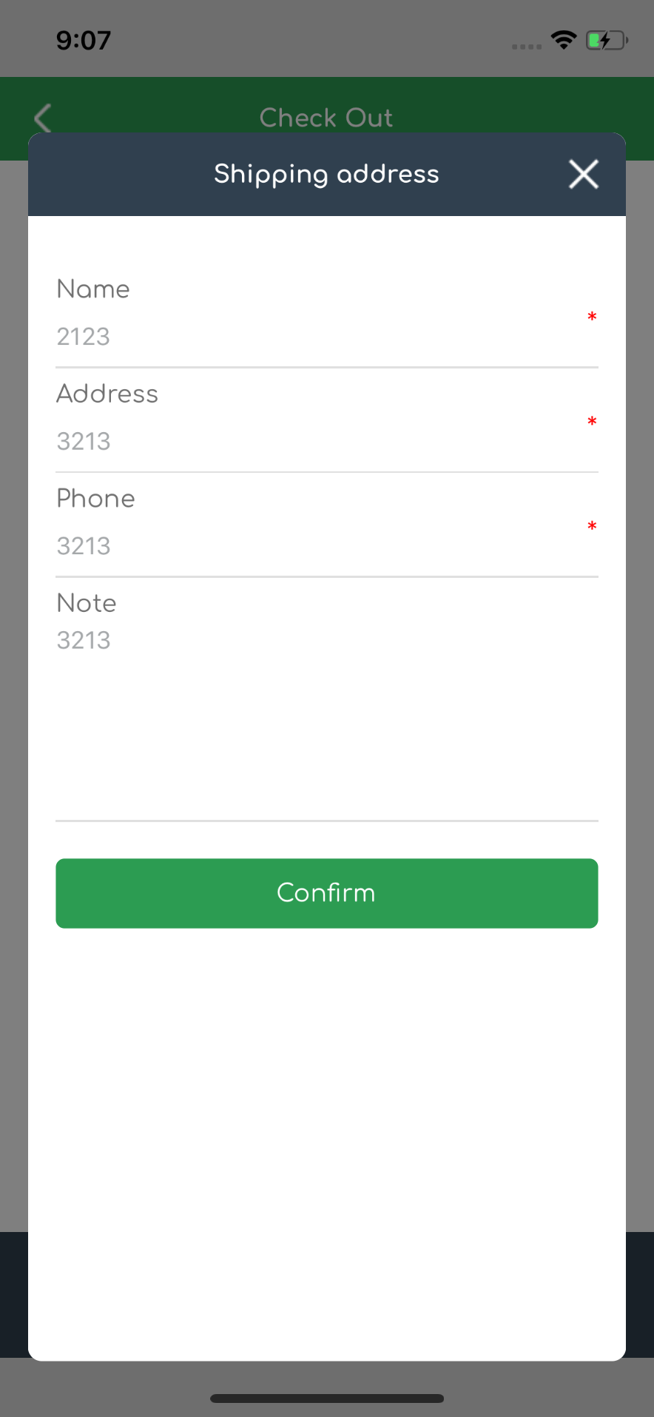

Form Input detail:

* Name: required
* Address: required
* Phone: required
* Note

Function:

* Confirm:
  +  Check all validation right: Save shipping address detail
  + Show error if any validation wrong

## Payment method popup

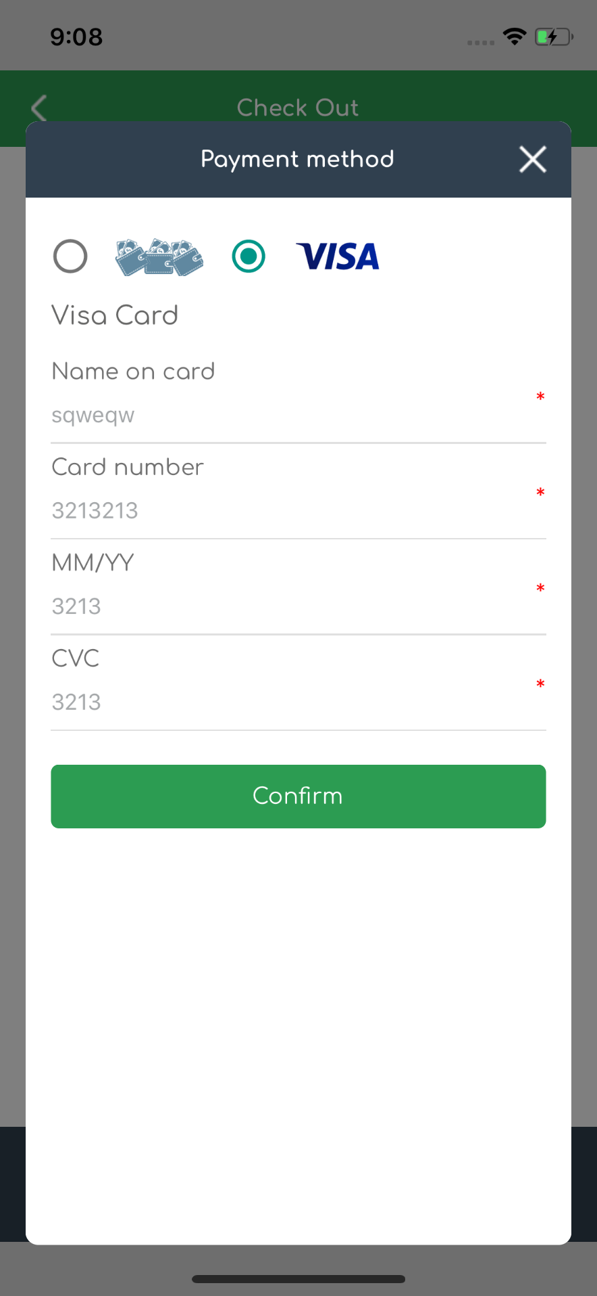

Form Input detail:

* Name: required
* Card number: required
* MM/DD: required
* CVC: required
* Payment method:
  + Cash on delivery
  + Visa

Function:

* Confirm:
  +  Check all validation right: Save shipping address detail
  + Show error if any validation wrong

## Confirmation page

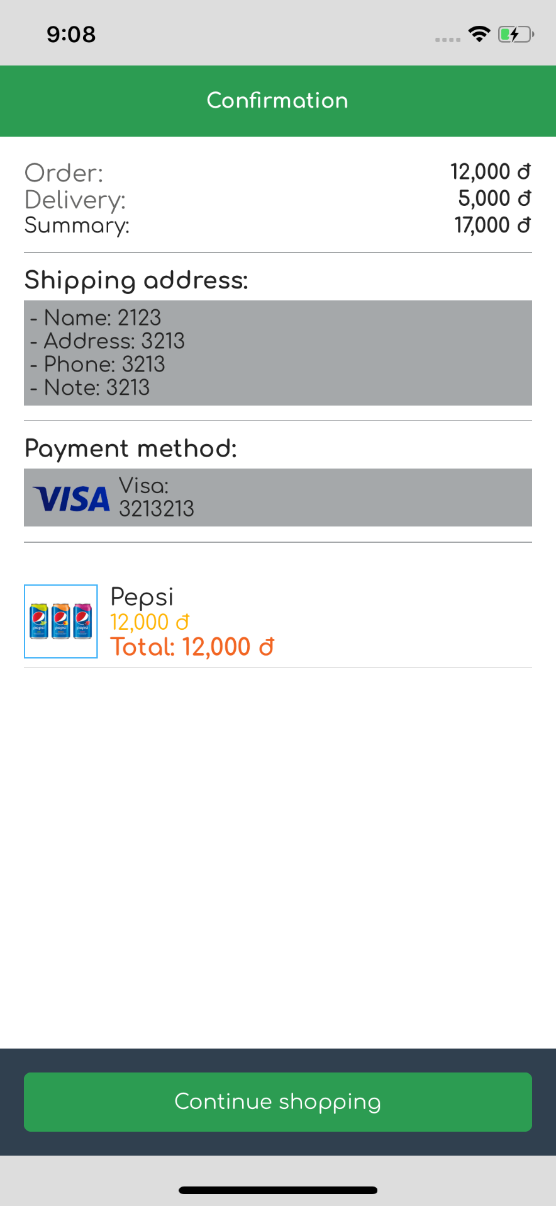

Show confirmation detail:

* Order money
* Delivery fee
* Summary money
* Shipping addres
* Payment method
* List item:
  + Image
  + Name
  + Price
  + Total price

Function:

* Continue shipping:
  +  Navigate to home page